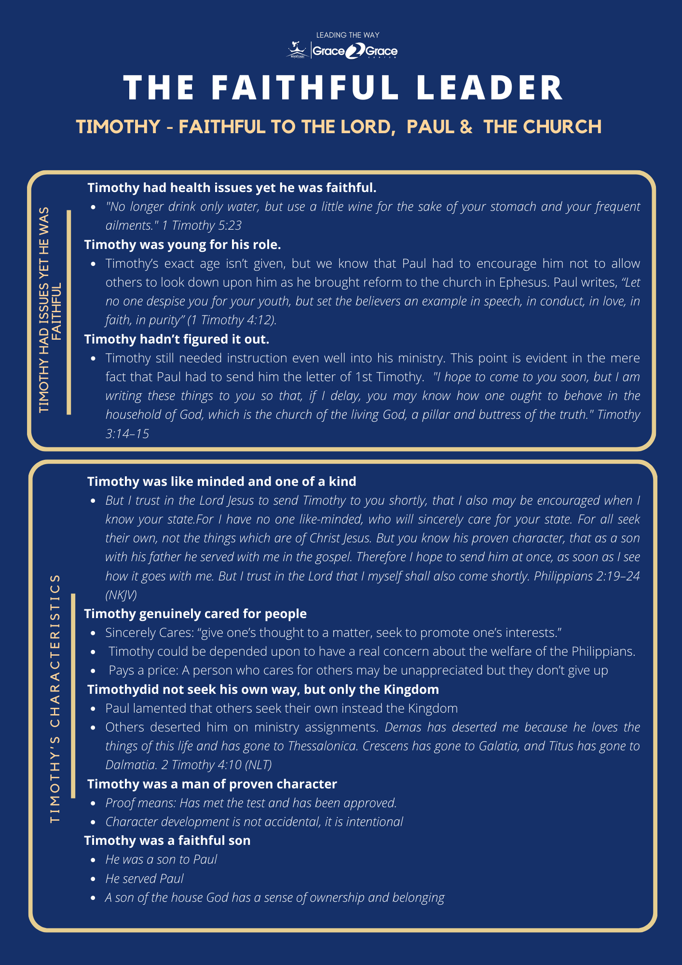



|  |  |
| --- | --- |
| **Likeminded/One of kind** | **What do you understand by Paul’s statement. *“…I have no one like-minded…”*** |
| **Can your Pastor say that you are:**   * One of kind? **Y / N** * Faithful in your person walk with God? **Y / N** * Faithful in executing your duties in church? **Y / N** * Faithful in tithes, offering and other forms of giving? **Y / N** * Faithful in church attendance and participating in church events and activities? **Y / N** * Readily available when your help/services is needed? **Y / N** |
| **If you did not answer yes to all of the above. In which areas must you improve and how are you going to do that?** |
| **What are you next steps you are willing to take?** |
| **Genuinely cares for the people** | **As a Leader in what 3 ways can you sincerely care for the people?** |

|  |  |
| --- | --- |
| **Does not seek his own but the Kingdom** | **What are the things that you focus on that takes your attention from your relationship with God and your role in the church?** |
| **What changes do you have to make?** |
| **Man of Proven character** | **Character development is not accidental, it is intentional. Do you have a plan to improve your character?** |
| **Are you following the plan?** |
| **Faithful Son** | **A son of the house God has a sense of ownership and belonging. What do you thing are 3 characteristics of a son of the house of God?** |